RESOLUTION NO.__________

RE: CERTIFICATE OF APPROPRIATENESS UNDER THE
PROVISIONS OF THE ACT OF THE PENNSYLVANIA
LEGISLATURE 1961, JUNE 13, P.L. 282 (53
SECTION 8004) AND BETHLEHEM ORDINANCE NO.
3952 AS AMENDED.

WHEREAS, it is proposed to construct a metal and glass greenhouse with brick base at the rear of the house at 53 E. Market St.

NOW, THEREFORE, BE IT RESOLVED by the Council of the City of Bethlehem that a Certificate of Appropriateness is hereby granted for the proposal.

Sponsored by: (s)

(s)

ADOPTED BY COUNCIL THIS DAY OF

(s)
President of Council

ATTEST:

(s)
City Clerk

HISTORICAL & ARCHITECTURAL REVIEW BOARD

APPLICATION #3: The applicant proposes to construct a metal and glass greenhouse with brick base at the rear of the house at 53 E. Market St.

OWNER: Virginia Fowler
53 E. Market St., Bethlehem, PA 18018
__________________________________________________________________

The Board upon motion by Phil Roeder and seconded by Nancy Shelly adopted the proposal that City Council issue a Certificate of Appropriateness for the following:

- The greenhouse will be connected with a shed link.

- The brick base will match the unpainted brick piers in the rear yard fence.

3. The greenhouse will be constructed of off-white prefinished aluminum framing
with 1” clear insulated glass panels for wall and roof.

4. Metal work color will match the trim color on the existing home.

5. The motion was unanimously approved.

__________________________________________________________________________

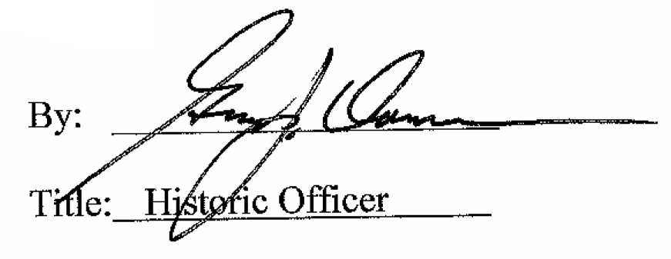

Date of Meeting: December 3, 2014

